At each clock tick, we also need to produce a cat image that is also based on the x-coordinate through a background scene

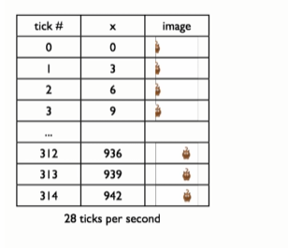

Function definition

* Puts the image of the cat at the right place (x-coordinate) on the empty scene (MTS).

